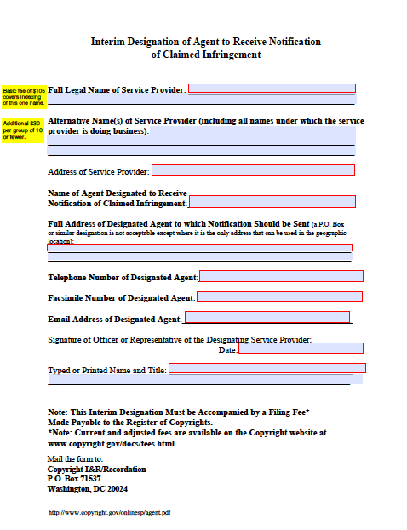

http://www.copyright.gov/onlinesp/

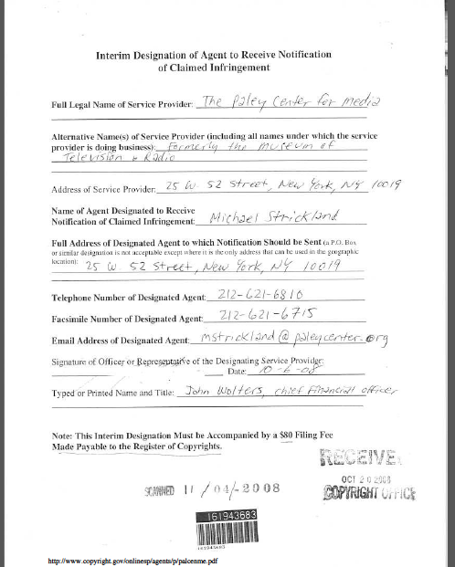

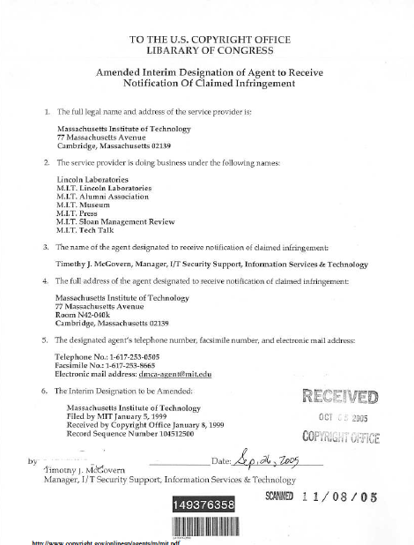

To qualify for safe harbor protection, a library that hosts content must:

- have no knowledge of, or financial benefit from, infringing activity on its network

- have a copyright policy and provide proper notification of that policy to its subscribers

- list an agent to deal with copyright complaints

A well established take-down and notice procedure is available to libraries that have registered an agent with the U.S. Copyright Office.

First, a copyright owner provides a proper notice to the library, with the following information:

- The name, address, and electronic signature of the complaining party [512(c)(3)(A)(i)]
- The infringing materials and their Internet location [512(c)(3)(A)(ii-iii)], or if the service provider is an "information location tool" such as a search engine, the reference or link to the infringing materials [512(d)(3)].
- Sufficient information to identify the copyrighted works [512(c)(3)(A)(iv)].
- A statement by the owner that it has a good faith belief that there is no legal basis for the use of the materials complained of [512(c)(3)(A)(v)].
- A statement of the accuracy of the notice and, under penalty of perjury, that the complaining party is authorized to act on the behalf of the owner [512(c)(3)(A)(vi)].

Then the library must expeditiously remove or disable access to the material. Alternatively, the library may choose to challenge the notice.

More information is at http://www.chillingeffects.org/dmca512/faq

