Workforce Development Plan for Recovery and Resilience
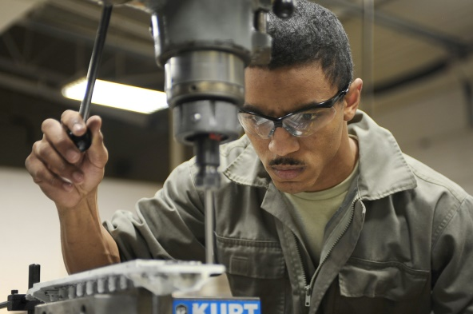

Note: boxes will expand to fill more text as you type.
Conduct a Needs Assessment
What are all the ways in which your library currently offers assistance to job seekers? In what ways are you now offering assistance due to COVID-19 that you were not before?

Who else in your area offers assistance to job seekers? (e.g. Public sector, government funded, potential partners for the library to work with in the future). Who/what is the largest employer in the area your library serves? Top five largest employers? Can you do a quick search to find if they are hiring?

Describe the need you see at your library from those looking for assistance in finding employment.

Describe what kind of assistance to job seekers you would like to use this plan for.

Identify Your Building Blocks of Workforce Development
Describe the “building blocks” that are already in place at your library to assist job seekers and support workforce development. (These could be literacy specific or job specific, e.g. resume assistance, cover letter assistance, job search help, one-on-one appointments, zoom mock interviews)

Describe the strategies, resources, and tools you can use to help a patron write a resume.

Describe the strategies, resources, and tools you can use to help a patron write a cover letter.

Describe the “building blocks” you would like to add to your library to assist job seekers and support workforce development.

Workforce Development Strategies for Target Customer Populations and Marketing Plan
Now is the time to focus what your intent is in assisting job seekers and spend some time thinking about the first steps to assist them. In the space provided below (or in another place):
1) design a digital handout listing resources for job seekers in your area OR
2) create a programming outline for a workforce development event or a digital event flyer inviting patrons who are looking for more information on jobs/careers OR
3) identify a specific population you would like to target (teens, ex-offenders, recent college grads, etc.) and describe the strategies you will use to identify and address the specific needs of this group—you can use the chart below to help get started

 | Strategy 1 | Strategy 2 | Strategy 3
Teens
Soon-to-be Grads
Recent Graduates
Re-Entry
Ex-Offenders

Putting Your Plan Together: Resources and Partners

List the resources you will need to put your plan into action. (Time, Materials, Cost, Human Resources)

List potential partnerships and collaborations: Who are they? What do they bring to the table?
Partner Name | What the partnership/collaboration brings to the table

List the goals of your partnership. Describe the services you believe you can provide in conjunction with your partners through your collaboration.

How will you measure your success?

