 | Every year that you don’t increase your materials budget you’re effectively cutting it—the cost of budget and processing of books increases 5-7% every year.
Policy guides: Where you select. What you select. Who selects.

Plan guides: When you select. Why you select. How you select.

Policy shouldn’t change year to year but plan should be updated regularly.

Examples of goals:
- 80% annual turnover in picture books, median collection age of 5 years in 600s.
- Weeding timelines—entire collection evaluated and weeded every 12 months
- Identified needs—what areas you will focus on in the next year.
- What would you do if you suddenly had money?

Language—demographics alone shouldn’t dictate how you divide up your budget
Socio-economic—can drive the tipping point on adoption of new formats and technology
Ages– children’s books cost less but there are more formats

Why don’t they use library? They don’t know about it. They don’t need it/They don’t think they need. Inconvenient.

Go to Governing Authority with real statistics and a plan
Seeking out grants from Friends or other sources
This is where we are, this is where we should be, this is how we’ll get there.
What we need, why we need it, how we’ll do it, how we’ll maintain it .

Just like in your home there are options for scaling your expenses. If you have a fixed income and your rent goes up, you cut back someplace else but you need to have the essentials.
So what are the essentials for libraries?
If you have areas and priorities for growth identified you can allocate additional funds to those areas when they are available.

Standards can be a good starting point but should be adjusted to meet local needs and use patterns.

Does the cost of databases and/or econtent come from your materials budget or is it separate? Does it matter?

Circ by area
Turn over rate
Shelf “real estate”
Copyright age
Last circ
Cummulative circ
Date added
Circ per year –per last 3-5 years

 | Good selectors develop a “feel” for what will be popular or what the community needs. However, these decisions are not based solely on gut instincts, they are informed by knowledge of how the collection is used, reviews, being aware of popular authors, etc.
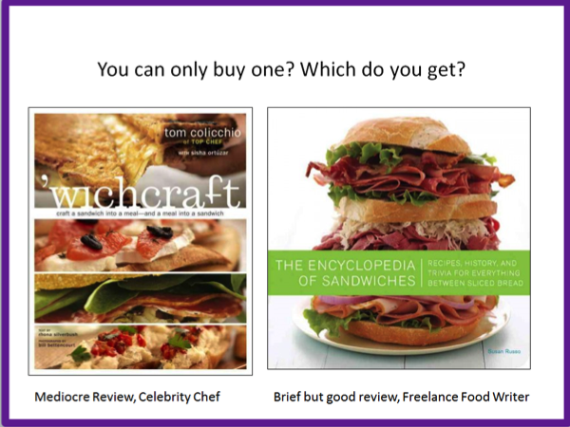 | Having guidelines for selectors that are tied to your goals and budget allocations is essential.  If you are working with a severely limited budget you need to decide early on if you are going to be guided primarily by star reviews, popularity and requests, circulation, etc.
Has adoption/ownership of a new technology reached a certain percentage of the population – do you serve a community of early adopters? Accept that you may need to purchase same title in more than one format.

When removing—consider the impact—look at circs! Allowing things to die via attrition vs. wholesale deselection.

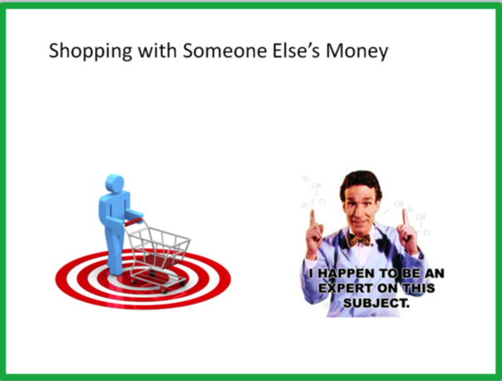 | Models of selecting: centralized, decentralized, hybrids  Experts don’t have to be professionals or even staff.
Reviews…how important are they?
Traditional resources
Crowd sourcing
Popculture

What you should know about the publishing world…

Publishers control market not reviews

Marketing in many cases drives demand

Times you *really* want to use reviews:

Filling collection gaps.

Considering whether to add a donation.

Can you really compare ebooks to print?

Usage of music CDs has dramatically fallen off in recent years in our libraries.

Products like Zinio are making libraries rethink the need for print magazines.

Need to address self-published materials as a part of your collection development plan and policy.

Consider: 1) only add those books of local interest—often the best local history resources are self-published. 2) consider adding donations by local authors and even creating a special shelf in the library to highlight local authors.

Also, watch for real world usage.

What academic libraries are trying.

Using dummy records.

Balance demand with decimating your budget.

Does PDA skew the collection?
 | If you have an older collection, don’t have expertise in local reports, guidance from a community of users can be useful
Weeding needs to be a part of your collection development plan.

Lease or Purchase?

 | Statistics show that having fewer books on the shelf, provided they are good books, equals better circulation.
Key word is Continuous

Using CREW as a model, go through your collection development plan and set goals and local standards for specific collections, formats, and subject areas.

- Find the person on staff who enjoys it
- Let paraprofessionals and volunteers pull items for evaluation
- Start with the no brainers – duplicates, ugly copies, “dusty” books
- Do it in cycles rather than all at once

jennifer@shpl.org
Anthony.halstead@countyofnapa.org

