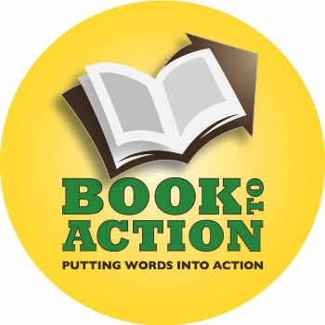
Book To Action: Putting Words Into Action
And Expanding the Library’s Role in Promoting Civic Engagement

Tuesday, October 6, 2015
Presenter: Mary Menzel, California Center for the Book
mmenzel@calbook.org
http://booktoaction.library.ca.gov

Book to Action:
- Engages community members in collectively reading and discussing a book
- Puts their new-found knowledge into action by offering a community service project related to the book's topic.
- Helps you collaborate with local organizations doing vital work in your community
- Expands your library’s role by mobilizing volunteers in work that enhances civic engagement.

Book to Action is not a grant and is not a reimbursement program. California Center for the Book will pay invoices on your behalf, up to $3,000, for books to give to community members; author fees; and author travel.

Application form, “2016 Request to Participate,” will include:
- Amount requested ($3,000 maximum)
- Title of selected book(s)
- Description of the program(s) to be conducted, including information on speaker(s), topic, and community service activity. (200 words maximum)
- Proposed community service partner(s) and their anticipated role in the project
- Intended audience (e.g. adults, school-aged children, specific target populations)
- How many people are expected to participate
- Anticipated outcomes of the program
- A brief outline of expected program expenses and funding sources. No minimum cash match or in-kind requirement.

Deadline for request to participate: December 1, 2015 – 5 pm
Notification will be made by: December 15, 2015
All programming must be complete and invoices submitted to CCFB by: Friday, May 13, 2016
Final narrative report due by: Tuesday, May 31, 2016

Book to Action is supported by the U.S. Institute of Museum and Library Services under the provisions of the Library Services and Technology Act, administered in California by the State Librarian.

